**CESMII OPC UA Nodeset Utility**

**User Guide**

|  |  |  |
| --- | --- | --- |
| **Version** | **Date** | **Summary** |
| 1.0 | 10-26-2022 | Initial version |
| 1.01 | 11-14-2022 | Updated to include additional clarifications |

This document is intended to assist in the setup and use of the OPC UA Nodeset Utility. The Utility provides the capability to convert standard OPC UA Nodeset XML files into Savigent platform models. The utility can also convert exported Savigent platform models to an OPC UA Nodeset XML format. In both cases, the XML or model in question will need to be consistent with some standards in order to be converted successfully.

**Setup**

The utility can be run by using the executable and app config files, these files should be placed in an accessible file location:

* UANodeSetConverter.exe
* App.Config.xml

**Configuration**

Before running the conversion utility, update the configuration file according to your goals.

1. The config file can be found in the Nodeset Graph folder, named “App.Config.xml”

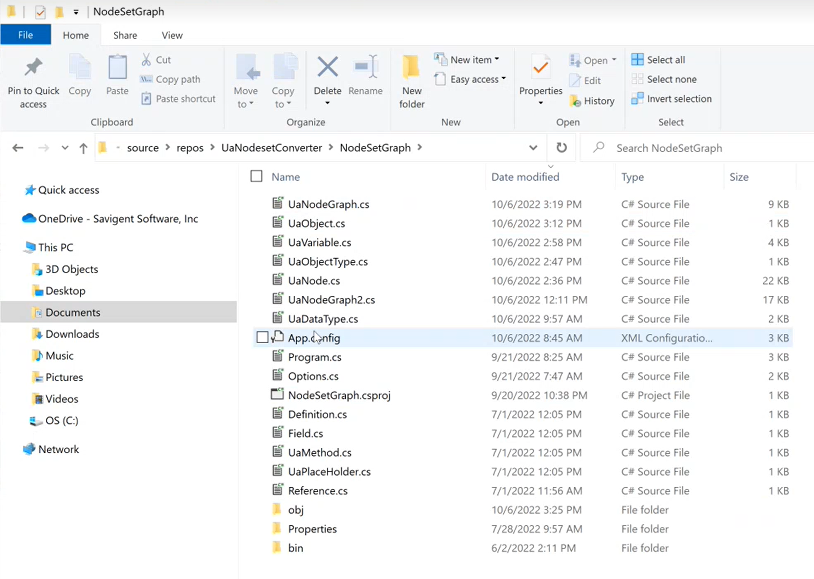

1. This config file can be opened with and edited by any typical XML editor, or Notepad.

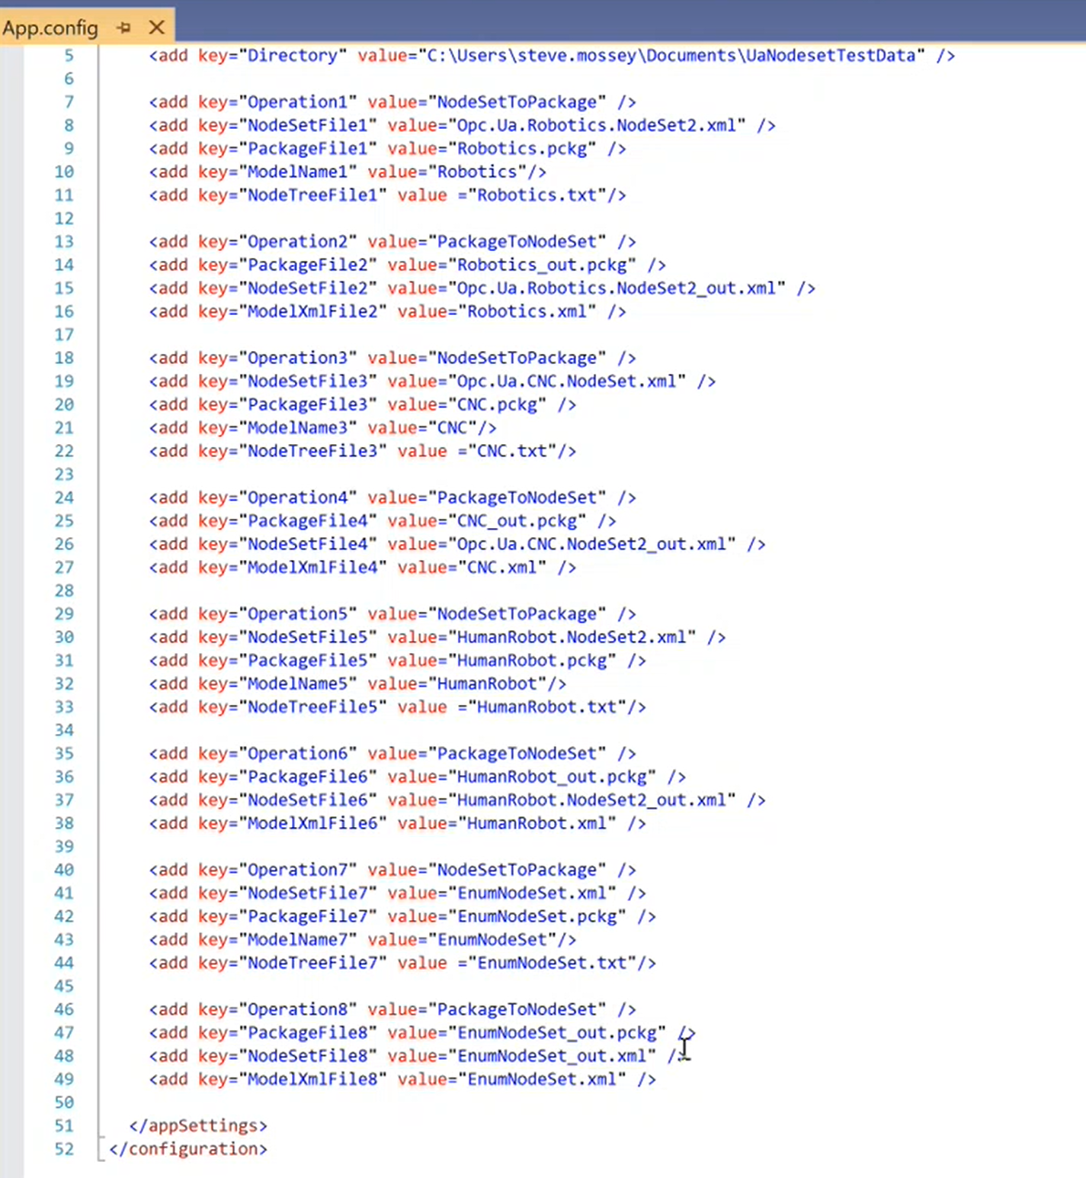

1. Verify and update the configuration as needed. The config details are:

<add key="Directory" value="C:\Users\steve.mossey\Documents\UaNodesetTestData" /> work directory

<add key="Operation1" value="NodeSetToPackage" /> operation: convert node set to Platform model

<add key="NodeSetFile1" value="Opc.Ua.Robotics.NodeSet2.xml" /> input file: node set file to be converted to Platform model

<add key="PackageFile1" value="Robotics.pckg" /> output file: model package file for import to Platform

<add key="ModelName1" value="Robotics"/> Platform model name

<add key="NodeTreeFile1" value ="Robotics.txt"/> output file: tree of converted nodes for reference only

<add key="Operation2" value="PackageToNodeSet" /> operation: convert Platform model to node set

<add key="PackageFile2" value="Robotics_out.pckg" /> input file: model package file exported from Platform

<add key="NodeSetFile2" value="Opc.Ua.Robotics.NodeSet2_out.xml" /> output file: node set converted from Platform model

<add key="ModelXmlFile2" value="Robotics.xml" /> output file: Platform model xml for reference

**Executable (convert XML to Model)**

Once the config file is edited, the utility can be run by activating an executable:

1. The command line interface can be run with this executable: UANodeSetConverter.exe
2. Select the appropriate option to convert the XML file to the model. The executable will repeat the available options when this action is completed:

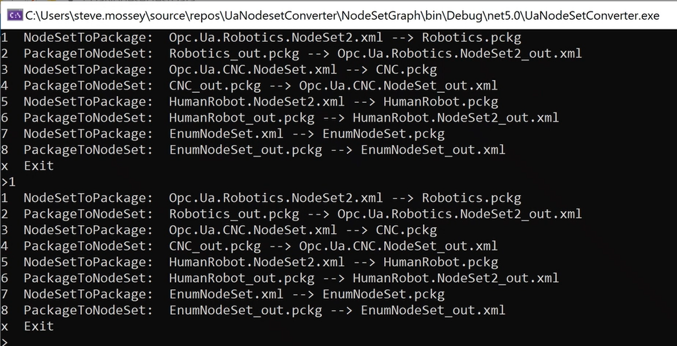

1. A Savigent model package file will be output.

**Import**

Before beginning, a few considerations should be understood:

* To be converted, NodeSet XML files should follow the standard format. Not all components of the NodeSet XML are included in the conversion, for example methods and actions are outside the scope of this version of the utility.
* Some NodeSets contain references to other NodeSet files. The utility currently does not import these references when executed, it will proceed with the conversion with the available data in the target file.
* These package outputs will be loadable to Savigent version 8.3 and subsequent compatible versions.

To import the package file to Model Designer in System Management

1. Open System Management
2. Switch to the Model Designer Plugin

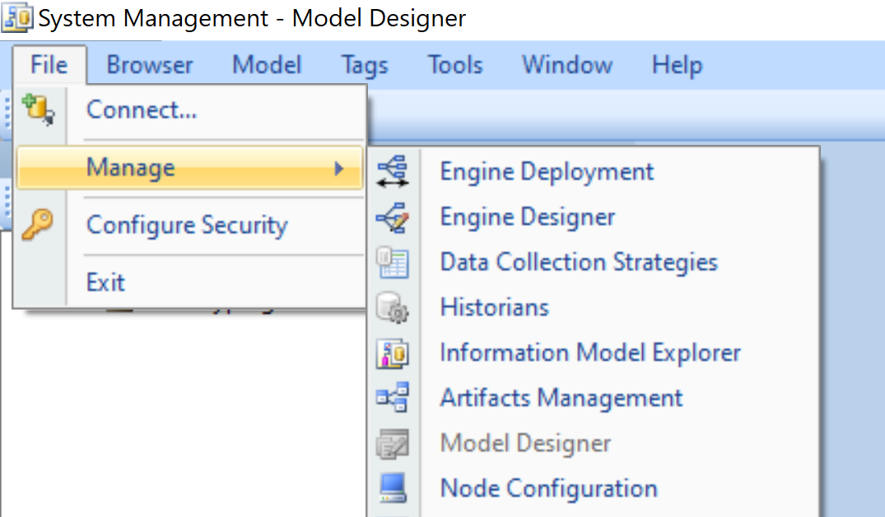

1. Right click on “Models In Browser” and select “Import from Package File”

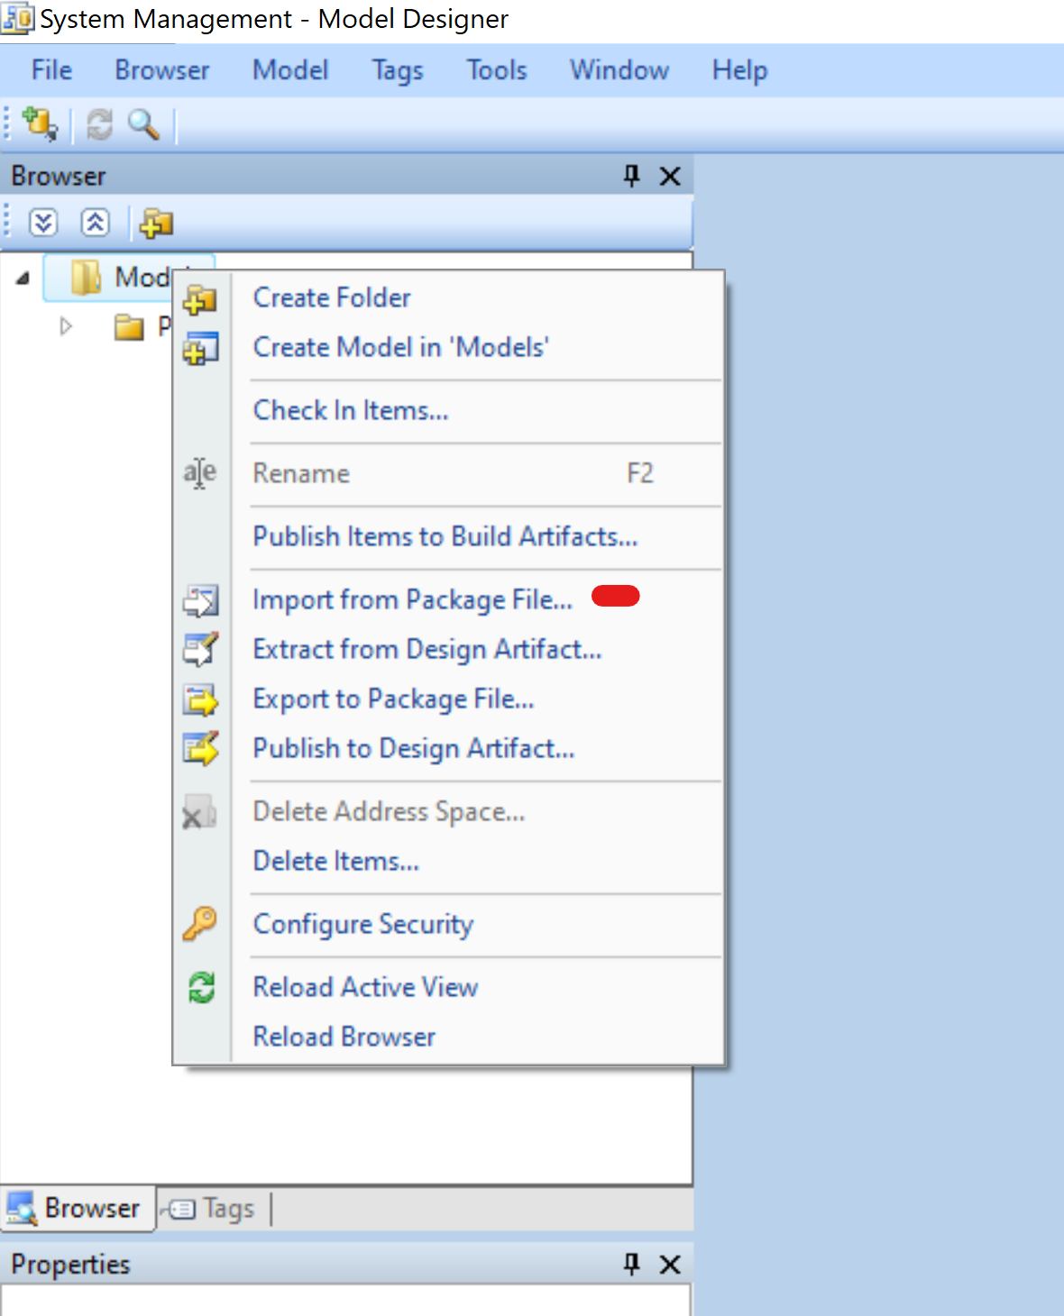

The datatypes of the OPC UA NodeSet XML will be visible in a nested Savigent Model:

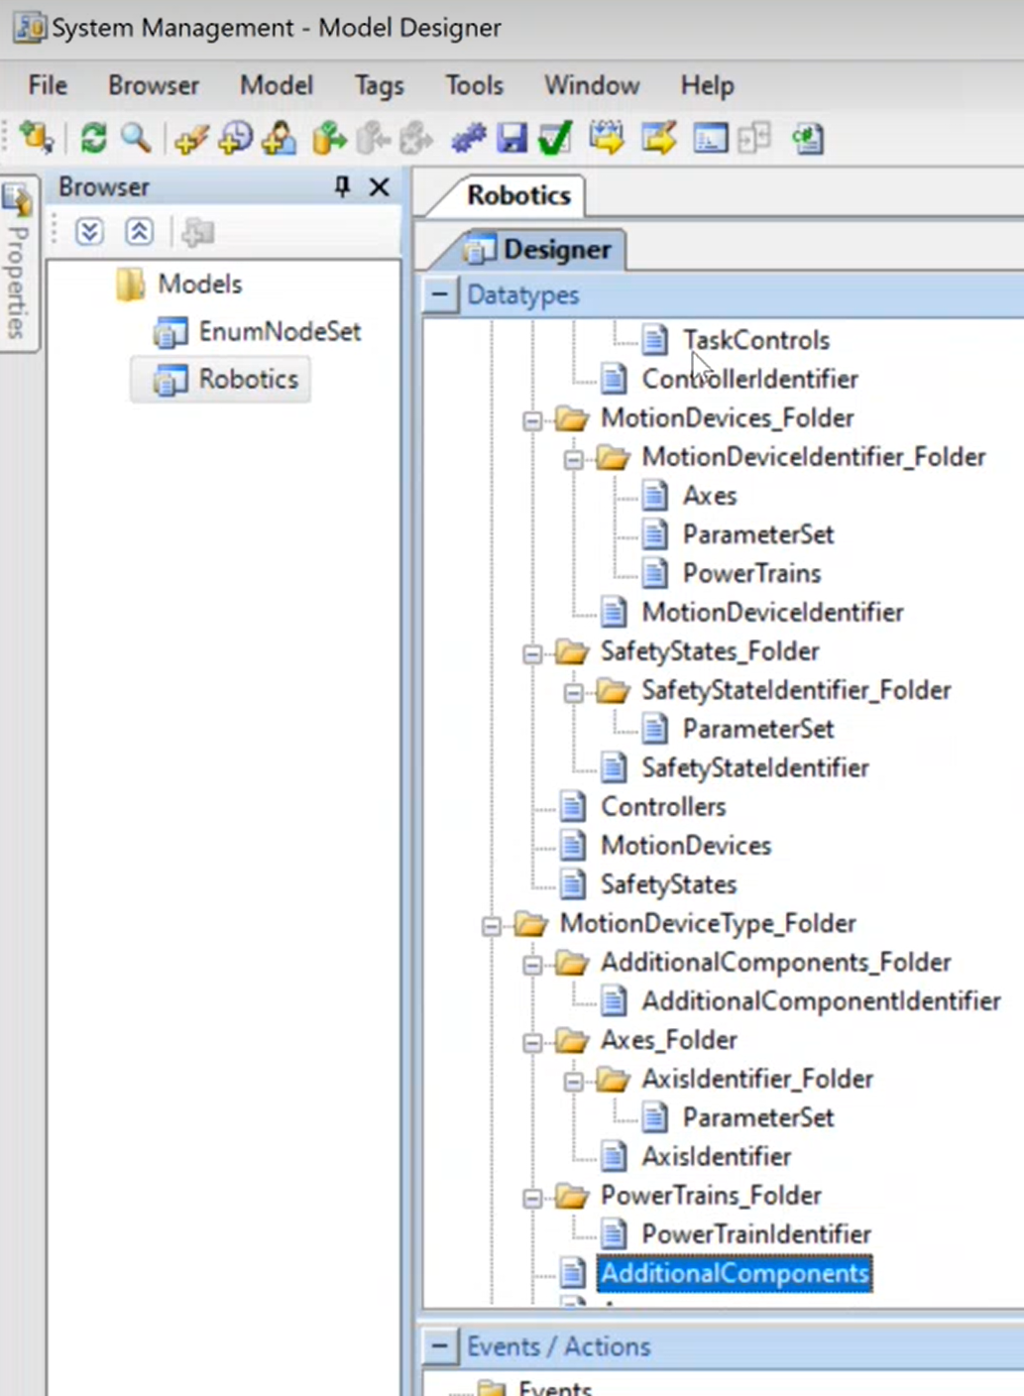

**Export**

To export a model and convert it to a NodeSet XML file, a few considerations should be made:

* In order for a model to be exportable, it must only consist of datatypes.
* As a design practice, if a model is anticipated to be exported at some point, separate models should be used for data types and other elements, such as actions and events. The data types model would be fully convertible, the other model(s) would not be.
* Node IDs are necessary to be populated in the description of each data type, according to convention. More specifically:
  + There are four kinds of ids that can be encoded in the Description field in Model Designer:

Code     Meaning

i              Node Id

s             Subtype

t              Type Definition

m           Modelling Rule

* + Here are example Description fields from the sample model:

Item                                    Description

Car                                       i:1.6  t:58

Manufacturer                   i:1.2  t:68  m:78

Model                                 i:1.3  t:68  m:78

Year                                     i:1.4  t:68  m:78

Price                                    i:1.5  t:63  m:78

Color                                   i:1.7  t:1.1  m:78

ColorEnumeration           i:1.1  s:29

A unique node id must be specified for every type and every member field of a set type.

This is required for the exported node set to valid.

Enumeration types should have subtype **s:29**.

* + If a set type field has a defined custom datatype, then the Type should be set to Object

and the node id of the custom datatype should be specified with the t code as shown.

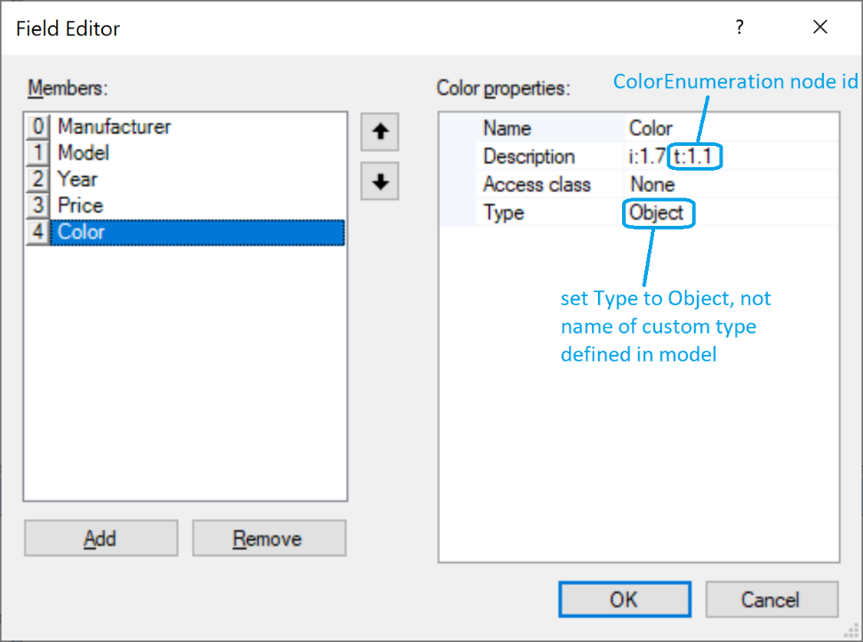

* + The codes below are not required for a valid node set.  They may be included to create references in the node set.

t codes – create HasTypeDefinition reference

68          PropertyType – causes field to appear as property in the nodeset

63          BaseDataVariableType – causes field to appear as variable in the nodeset

58          BaseObjectType – used

m codes – create HasModellingRule reference

78          Mandatory

80          Optional

* + A simple example model for reference is embedded here, titled “Car.pckg”.



* The structure of the model should also be considered and made consistent with an XML structure, including folders and nested datatypes as well as the appropriate associations of fields:

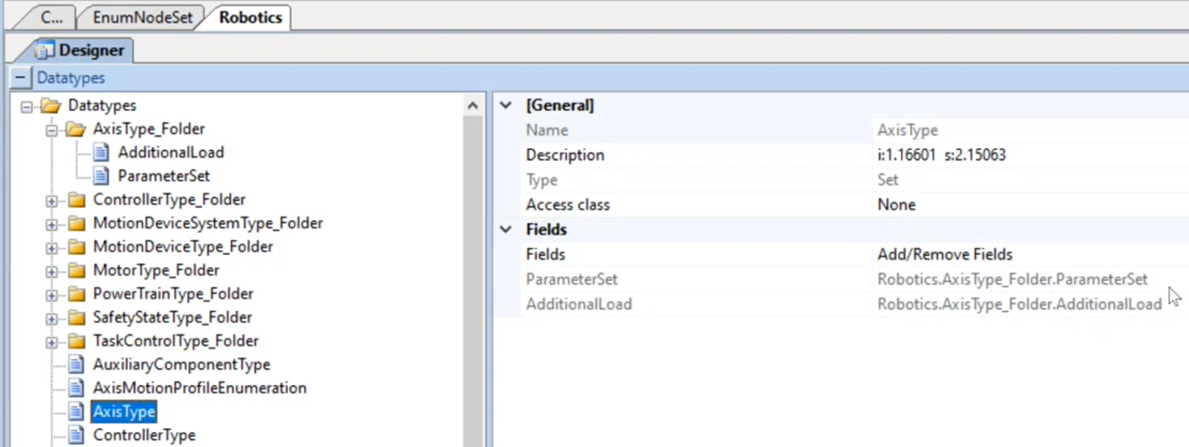

1. To convert a model to an OPC NodeSet XML file, first enter a Node ID in the description of each datatype:

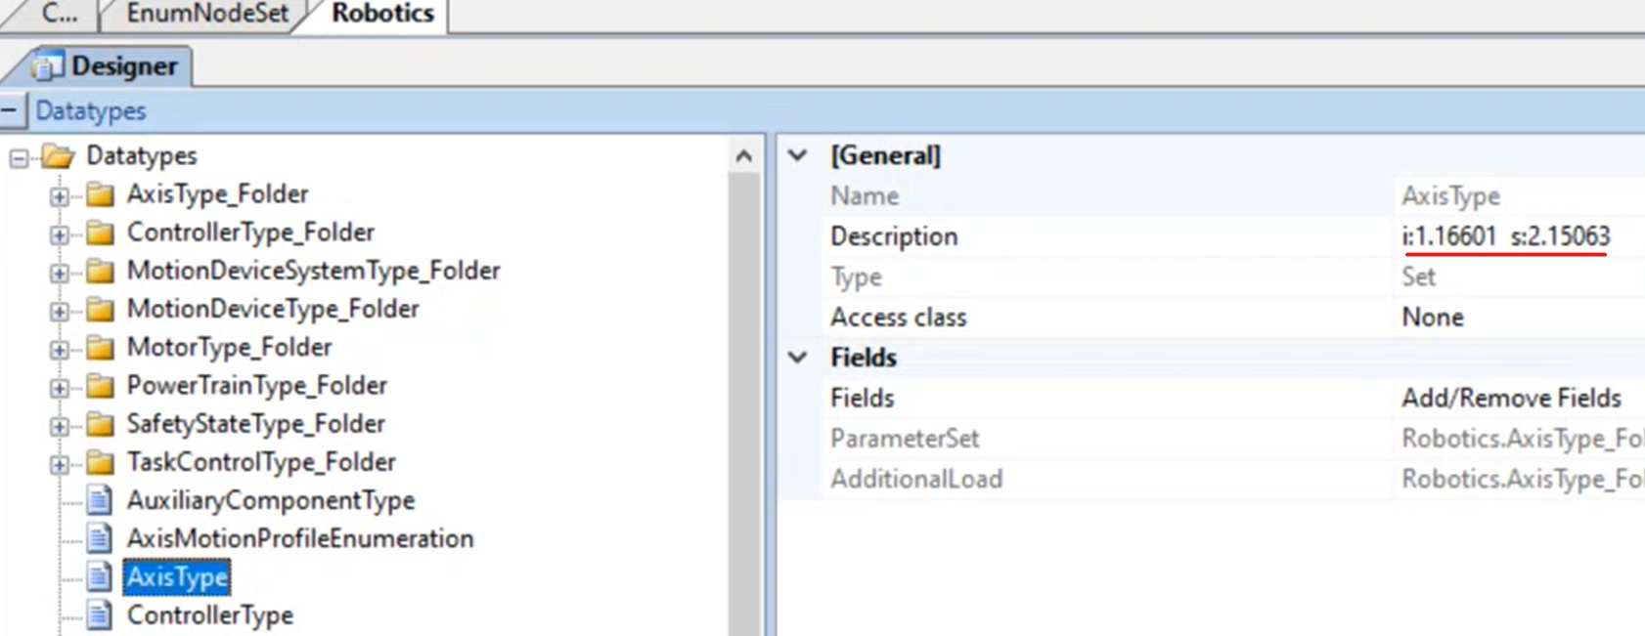

Consider the standards and formats when doing so. In this example, I:1.16601 is the Node ID, and S:2.15063 is the subtype node ID. The conversion will not be successful if these values are not provided.

1. In Model Designer, export the appropriate model to a package file:

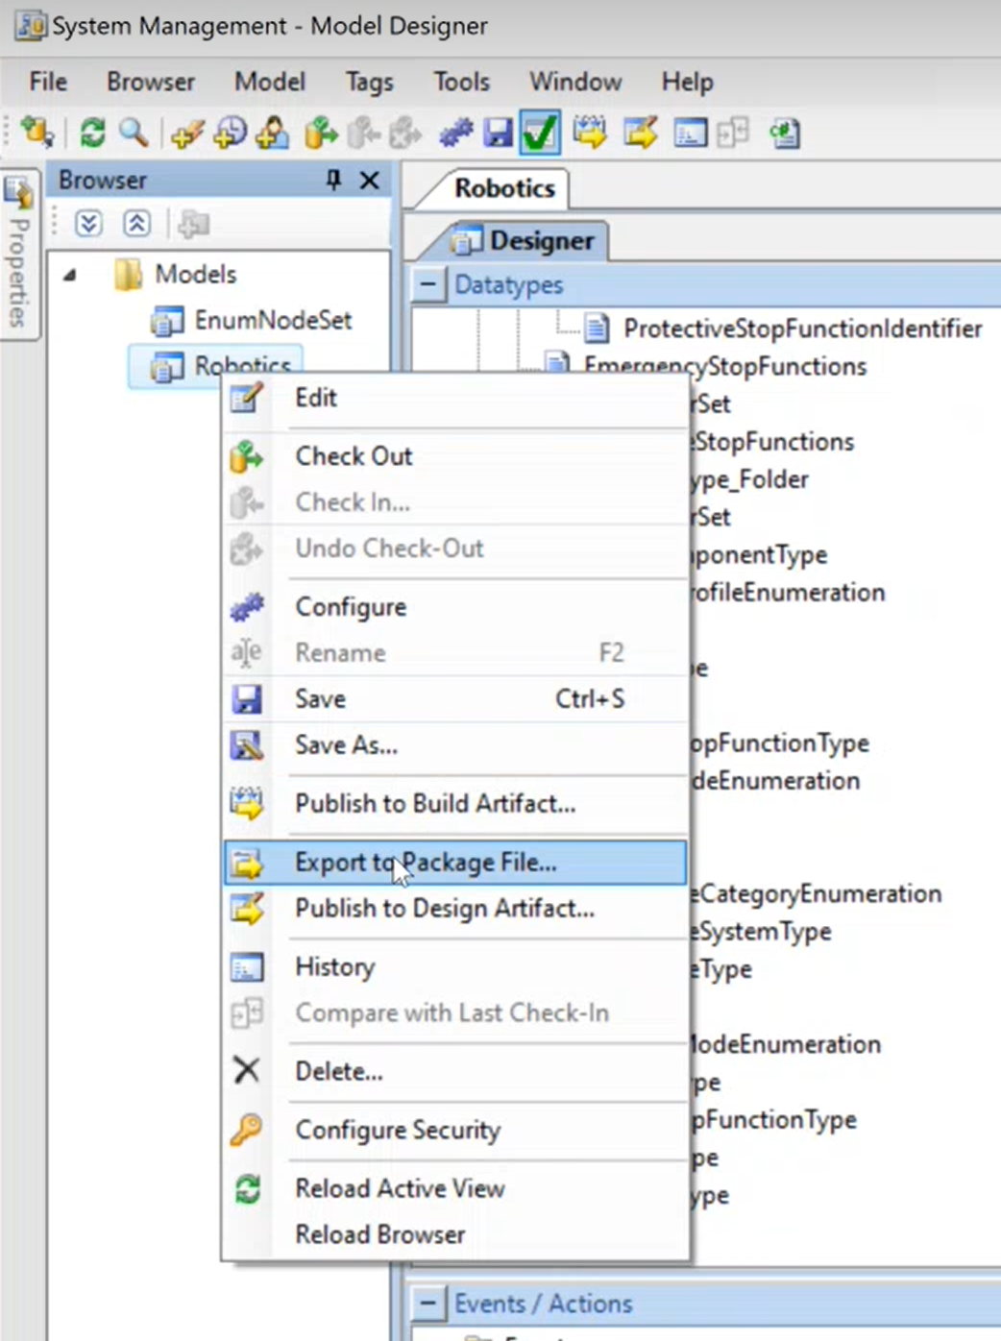

Choose an appropriate directory and unique file name.

**Executable (Model to XML)**

1. Run the UANodeSetConverter.exe.

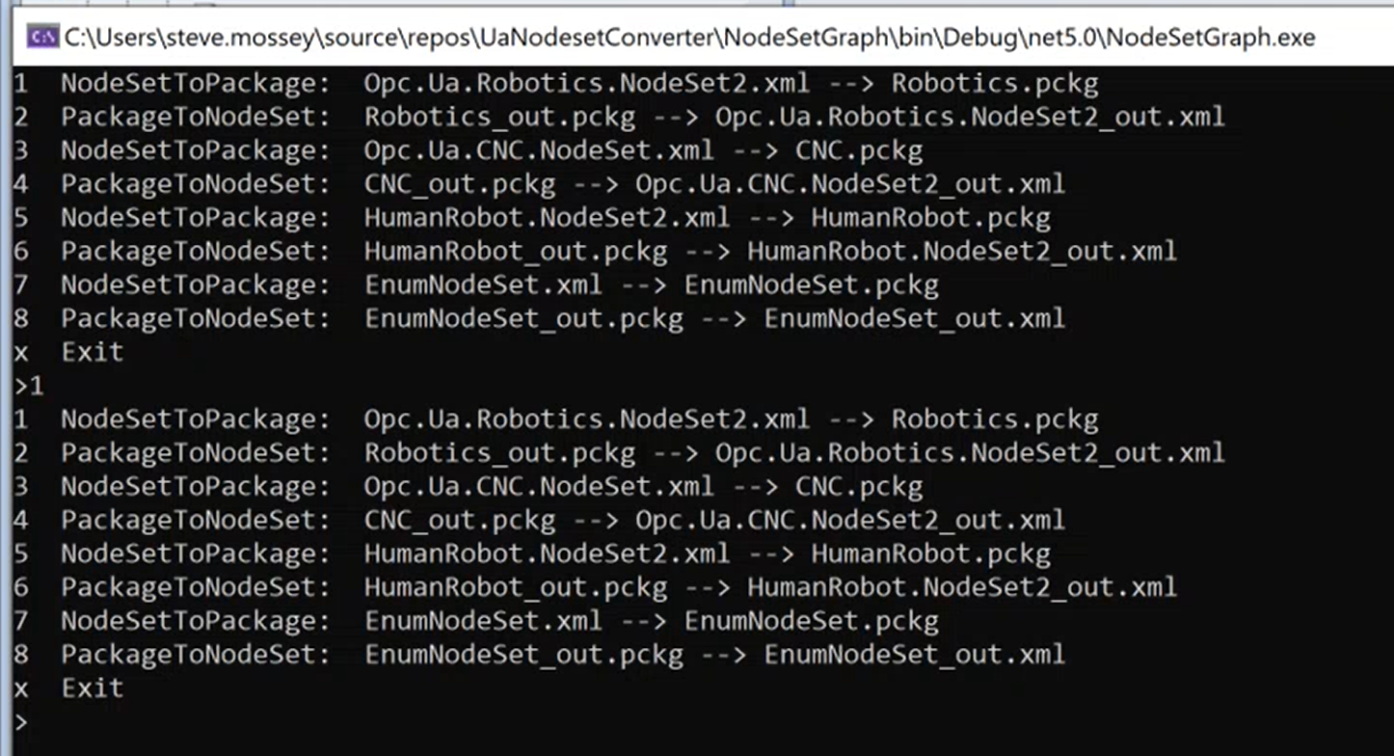

1. Select the appropriate option to convert the model to the XML file. The executable will repeat the available options when this action is completed.

To validate the XML file, a tool such as the Beeond UA Model eXcelerator can be used.